- In Cisco Packet Tracer, set up a simple network with one DHCP server and two client PCs. Configure the DHCP server to assign IP addresses automatically, then verify on each PC that it receives a different IP address from the DHCP pool.

Network Topology
- 1 × Server (DHCP Server)
- 1 × Switch (2960)
- 2 × PCs (PC0 and PC1)
Connect all devices to the switch using Copper Straight-Through cables.

Step 1: Configure the DHCP Server
- Click on the Server.
- Go to Desktop → IP Configuration.
- Assign a static IP:
  - IP Address: 192.168.1.2
  - Subnet Mask: 255.255.255.0
  - Default Gateway: 192.168.1.1
- Go to Services → DHCP.
- Turn the DHCP service On.
- Create a DHCP pool with the following settings:

Setting | Value
Pool Name | LAN
Default Gateway | 192.168.1.1
DNS Server | 8.8.8.8
Start IP Address | 192.168.1.100
Subnet Mask | 255.255.255.0
Maximum Number of Users | 50

Step 2: Configure the Client PCs
For both PC0 and PC1:
- Open the PC.
- Go to Desktop → IP Configuration.
- Select DHCP.
The PCs will automatically request an IP address from the DHCP server.

Step 3: Verify the Assigned IP Addresses
Check Desktop → IP Configuration on each PC.

Device | Assigned IP Address | Subnet Mask | Default Gateway
PC0 | 192.168.1.100 | 255.255.255.0 | 192.168.1.1
PC1 | 192.168.1.101 | 255.255.255.0 | 192.168.1.1

- Draw a sequence diagram (hand-drawn or digital) that clearly shows each step of the DHCP process: Discover, Offer, Request, and Acknowledge, labeling the sender and receiver at each stage.<br><br><em><strong>Hint:</strong> Use arrows to show the direction of each message between client and server.</em>

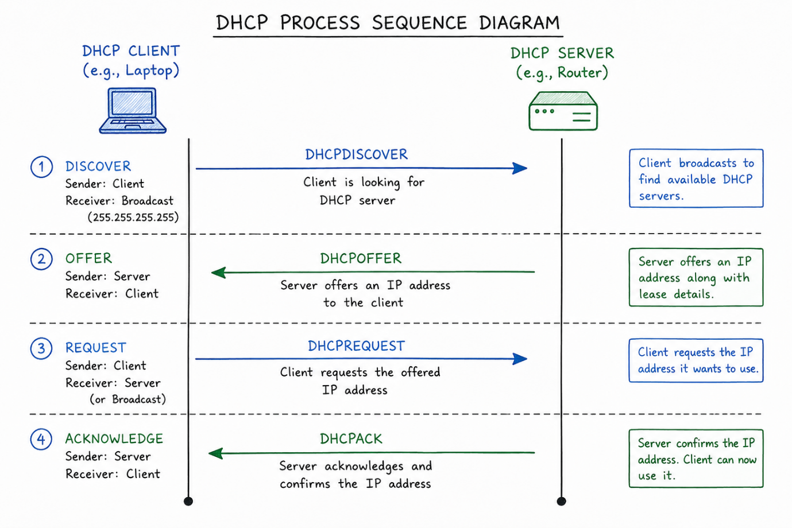

- Change the DHCP pool range on your Cisco Packet Tracer DHCP server so that only one IP address is available. Add two PCs and observe what happens when both try to get an IP address. Take a screenshot of the result and explain in 2-3 lines why only one PC succeeds.

- Place 1 DHCP Server, 1 Switch, and 2 PCs.
- Connect all devices using Copper Straight-Through cables.
- On the DHCP Server, go to Services → DHCP.
- Configure the DHCP pool so that only one IP address is available. For example:
  - Default Gateway: 192.168.1.1
  - Start IP Address: 192.168.1.100
  - Subnet Mask: 255.255.255.0
  - Maximum Number of Users: 1
- On both PCs, go to Desktop → IP Configuration and select DHCP.
Expected Result:
- PC0 receives an IP address (e.g., 192.168.1.100).
- PC1 fails to obtain an IP address and shows DHCP Failed or an address such as 0.0.0.0, depending on the Packet Tracer version.
Screenshot:
Take a screenshot showing:
- PC0 with a valid DHCP-assigned IP address.
- PC1 displaying DHCP Failed (or no valid IP address).

- Simulate a Zomato-style restaurant WiFi scenario in Cisco Packet Tracer: configure a DHCP server to provide IP addresses to both a laptop and a smartphone (use a generic PC as smartphone). Show the assigned IPs and explain why DHCP is useful in this situation.

Internet (Optional)
|
Wireless Router
|
-------------------
| |
DHCP Server WiFi Clients
/ \
Laptop Smartphone
(PC0) (PC1)

Configuration Steps
1. Configure the DHCP Server
- Assign the server a static IP:
  - IP Address: 192.168.10.2
  - Subnet Mask: 255.255.255.0
  - Default Gateway: 192.168.10.1
- Enable DHCP service with the following pool:
  - Pool Name: RestaurantWiFi
  - Default Gateway: 192.168.10.1
  - DNS Server: 8.8.8.8
  - Start IP Address: 192.168.10.100
  - Subnet Mask: 255.255.255.0
  - Maximum Users: 50

2. Configure the Wireless Router
- Router IP: 192.168.10.1
- Connect the DHCP Server to the router using a copper straight-through cable.
- Configure a WiFi SSID such as Restaurant_WiFi.

3. Configure the Clients
For both the Laptop (PC0) and Smartphone (PC1):
- Go to Desktop → IP Configuration
- Select DHCP
The clients automatically receive IP addresses from the DHCP server.

Device | IP Address | Subnet Mask | Default Gateway
Laptop (PC0) | 192.168.10.100 | 255.255.255.0 | 192.168.10.1
Smartphone (PC1) | 192.168.10.101 | 255.255.255.0 | 192.168.10.1

